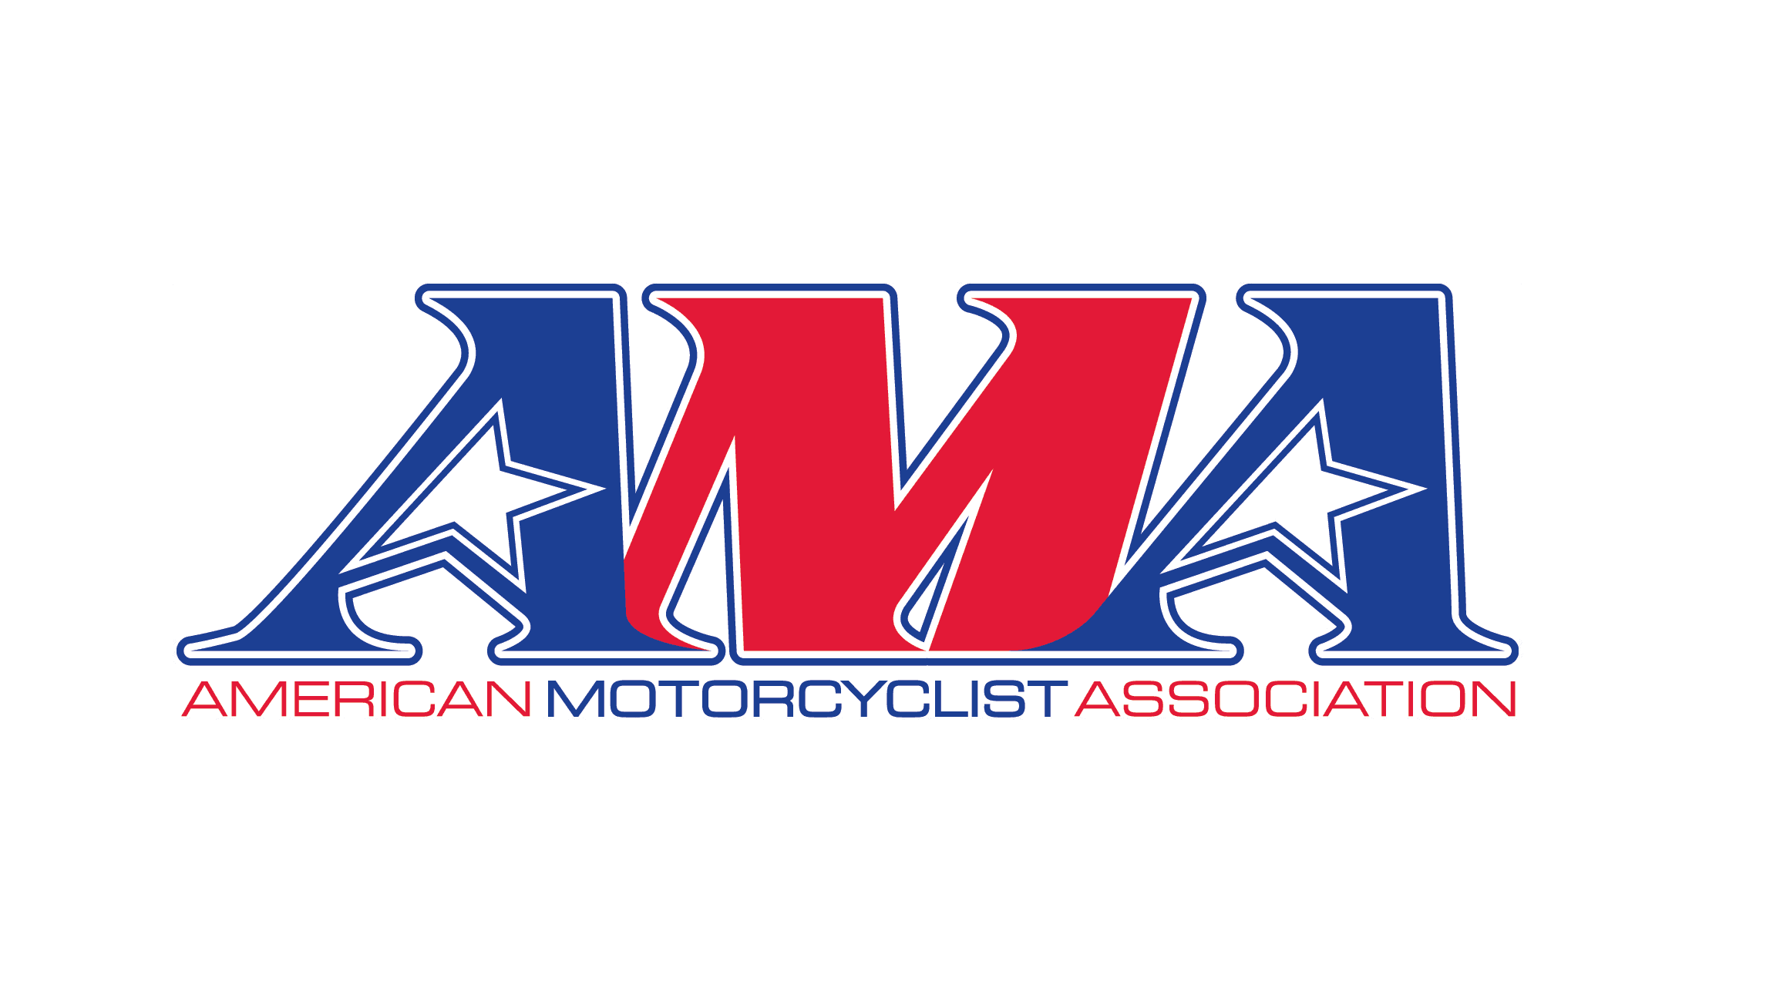

**American Motorcyclist Association**

**Motoclimb Super Series**

**Supplemental Rulebook 2025**

The following Rules supplement the current AMA Racing Rulebook

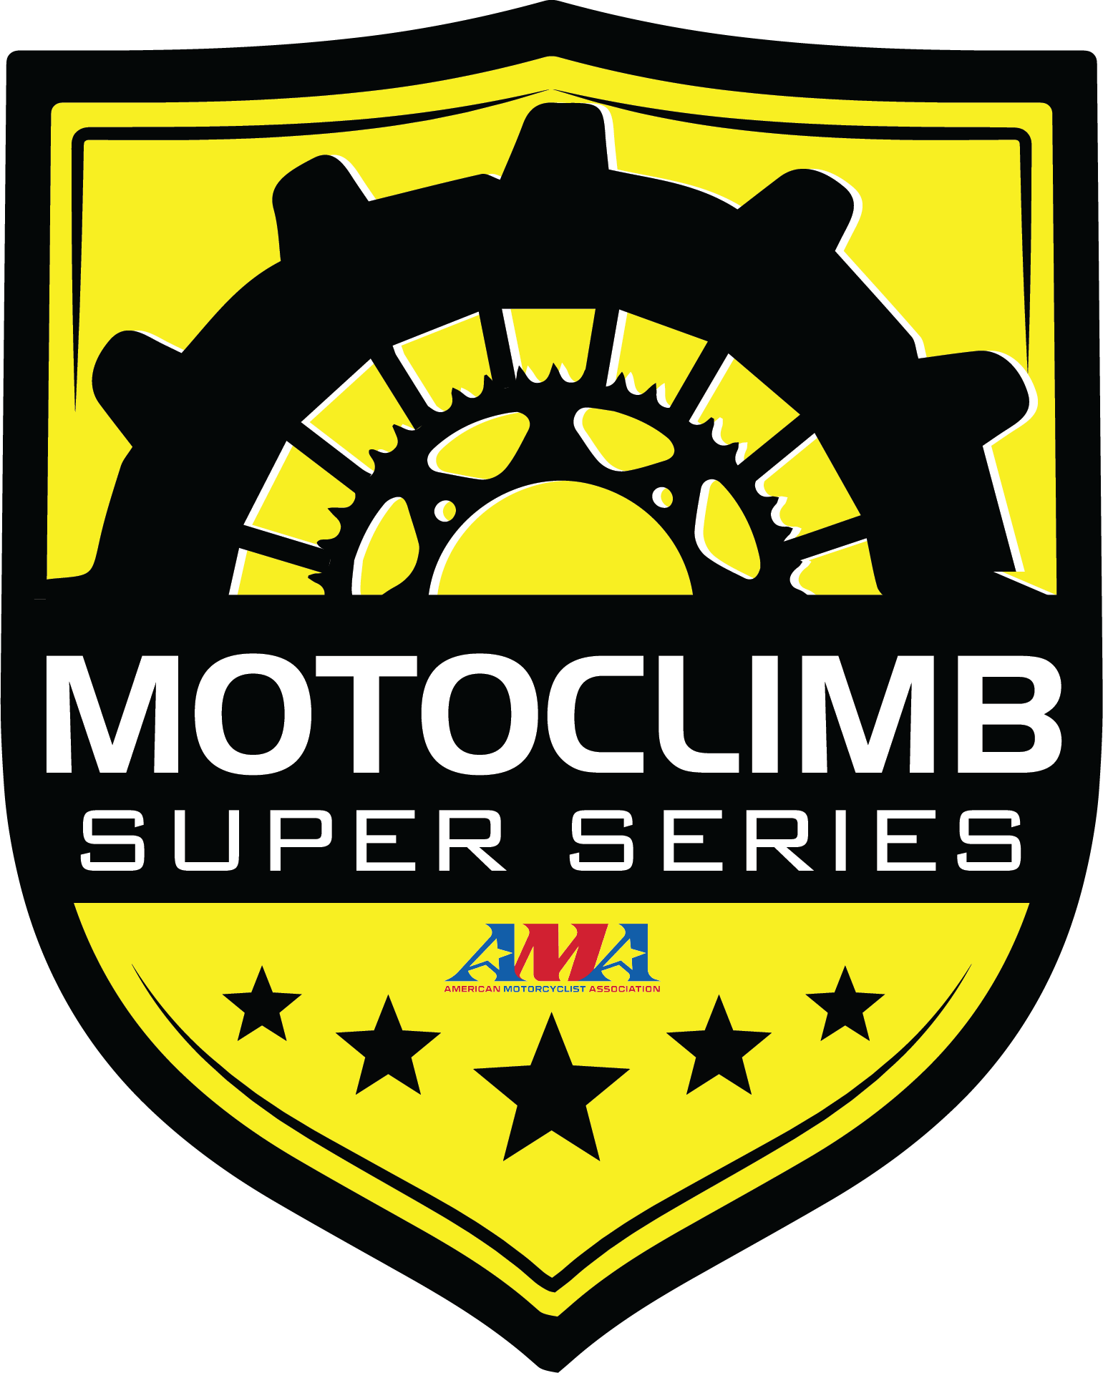

*These rules of competition are intended only as a guide for the conduct of the sport pursuant to uniform regulations, rules regarding or related to safety are promulgated to make all persons concerned with safety, but MOTOCLIMB Super Series neither warrants safety if the rules are followed nor compliance with and enforcement of rules.*

*Moreover, each participant in competition has the responsibility to assess the safety aspects of facilities and conditions and must assume the risk of competition.*



TABLE OF CONTENTS

CHAPTER TITLE PAGE

1. Competition Rules 4

General 4

Race Meet 5

Race Rules 6

Points 8

Purse 9

1. Rider & Pit Crew Apparel 10
2. Equipment Standards 11
3. Officials’ Duties 14

**CHAPTER 1 – COMPETITION RULES**

1. **General Rules**
   1. Participants:
      1. Every club, association, company, promoter, rider and other persons participating in or otherwise associated with Motoclimb Super Series are deemed to be participants and therefore bound by the MSS Rulebook.
   2. Entries:
      1. *AMA members* ***REQUIRED***  *All riders in AMA sanctioned competition are required to be* *AMA members or have an AMA issued on event pass. AMA associate members cannot participate in AMA sanctioned competition.*
      2. Each participant must pay **twenty dollars ($20.00) Motoclimb Super Series membership fee** **at each event** collected when entering for the event.
      3. Participant must be 16 years of age or older on the day of the event to enter events.
      4. Each class entry is considered a separate entry.
      5. Every participant in any of the classes must complete entry by the event entry deadline.
      6. Each entry must have a motorcycle for each class they enter. One rider per bike per class.
   3. Pit Regulations:
      1. Riding of competition motorcycles, other than on the hill or designated test area is not allowed.
      2. Any operation of a vehicle in the pit must be at a very slow and acceptable speed.
      3. Tow vehicles for towing motorcycles to the staging area will be allowed and must be driven at a slow and acceptable speed.
      4. Smoking is not permitted in pits, grid, signal area, or other restricted areas.
      5. Persons less than 16 years of age are not permitted in pits, grid, signal area, or other restricted areas.
      6. Pets are not permitted in pits, grid, signal area, or other restricted areas.
      7. Before leaving a race facility, it is the responsibility of riders / teams to deposit all of their waste fuel, fuel drums, motor oils coolants, tires, batteries, and all other hazardous waste in proper hazardous waste locations only. Should container not be available onsite, riders / teams must transport such materials from the facility for proper disposal.
      8. Pit bikes are not permitted.
   4. Riders Meetings:
      1. All riders entered in the meet must attend the riders meeting which should be held at least 30 minutes prior to the official starting time. Failure to attend riders meetings may result in disqualification
   5. Technical Inspection:
      1. Technical inspections of motorcycles, equipment and riding apparel will be held prior to and after a race meet and at other times at the discretion of the Referee or Chief Technical Inspector.
      2. Motorcycles maybe tech inspected any time before allowed on the hill.
   6. On Hill Regulations:
      1. No rider may, at any time, ride in such a manner as to endanger life or limb of other riders, event staff (including hill workers), officials or the public.
   7. Inclement Weather / Unacceptable Hill Conditions:
      1. In the case of inclement weather or poor hill conditions, the Referee and Promoter will determine a definite late starting time for the purpose of getting the hill in satisfactory condition, or for cancellation or postponement of the meet. Once a meet has started, the riders must be paid for all events run, and if at least 50% of the program has been run, it will be considered a completed program and the entire guaranteed purse must be paid.
   8. Provisional and Official Race Results:
      1. No official announcement of race results will be given until all scoring materials are examined and approved by the Head Scorer.
      2. Provisional results will then be posted and will become official if no riders directly request a recheck of the Referee or Race Director within 30 minutes of the posting of those results.
   9. Media release statement:

Please be aware that by entering this area, you consent to your voice, name, and/or likeness being used, without compensation, in films and tapes for use in any and all media, whether known or hereafter devised, for eternity, and you release all IRC Motoclimb Super Series events, promoters, clubs, Motoclimb LLC, its successors, assigns and licensees from any liability whatsoever of any 

* 1. Attendees or participants:

The race director, promoter, or host club reserves the right to dismiss any attendee from an Motoclimb Super Series event that is acting unsafe or becomes an issue with other attendees or participants.

1. **Race Meets**:
2. Motoclimb Meet Definition – A motoclimb is a series of trials against time or distance on a designated course. The courses shall consist of at least two
   1. (2) flags/markers spaced a minimum of 10 feet apart in which a rider must pass through for a competed run. The starting position will be behind the timing line.
3. Motoclimb Classes
   1. Open Class;
      1. 601cc and larger multi cylinder or 700cc and larger single cylinder – engine
      2. 1 rider on the hill at a time.
      3. 2 attempts at the hill.
   2. **PRO STOCK Class**; Qualifying will take the top 32 riders for PRO STOCK Main.
      1. **240cc-450cc 2 & 4-stroke (stock wheelbase)** or Equivalent Electric Motorcycles approved by Motoclimb.
      2. 1 rider on the hill at a time.
      3. 2 attempts at the hill.
   3. **PRO STOCK** Main; will be the top 32 riders from PRO STOCK qualifying.
4. **240cc-450cc 2 & 4-stroke (stock wheelbase)** or Equivalent Electric Motorcycles **70hp limit** approved by Motoclimb.
5. 2 riders on the hill at 1 time.
6. Minimum of 1 attempt at the hill (single elimination).
   1. **450**-700cc class must be minimum **450cc** maximum 700cc.
7. 1 rider on the hill at a time.
8. 2 attempts at the hill.
9. The Motoclimb events may have other classes along with Motoclimb Super Series classes on the same day or day before or after the event.
10. **Race Rules**
11. **No practice is allowed on any part of the hill to be used within 30 days prior to the event.** An exception to this rule is for media coverage approved by an official Race Director, preferably on an alternate course if available.
12. An electronic timing system must be used with light sensors at the starting line and finish line. A backup system is recommended. In the case of a malfunction, any other type of timing device or method can be used only with the approval of the Referee.
13. If the timing system should fail to work for any reason, and the rider completes the course, he may take another ride any time within the next ten riders, or he may elect to score a footage measured at the finish line.
14. If the starting line timing light is tripped, that effort will be considered a ride.
15. A ride will end at the point in which the rider fails to cross between the two gate markers. A rider will be called out of bounds if it is necessary for a hill official to repair or replace a gate marker. Footage will be given to the rider at the point where the (repaired or replaced) gate marker was hit.
16. If a rider does not finish the course, he will be given footage to the front axle at the point where his ride ended, or at the point where he lost control of the machine while inbounds.
17. Out of bounds rules will be defined by the Referee at the riders meeting. Riders deemed out of bounds based on these rules will receive footage at the point that they left the course.
18. If the promoter is not using the computer, a generated drawing system all riders or riders’ representatives will draw for riding positions. After the drawing, riding order will be posted in the pit area by rider number. Exchanging of rider positions is not permitted.
19. A rider must be ready when his name is called. The pit steward calls riders to the starting box, in drawing number order. The rider will be given 2 minutes when the Referee signals that the hill is clear. If he is not ready to make his ride at that time, he must leave the starting box.
    1. If that rider has mechanical problems, they are then given a 15-­‐minute grace period. The pit steward will log the rider’s name and time the grace period began on the pit board.
    2. The rider must be ready to re-­‐enter the starting box within 15 minutes or that rider will be forfeited. The rider with the last number drawn in his class has two minutes in the starting box plus the fifteen-­‐minute grace period if necessary.
20. No one is permitted to work on the hill without the permission of the meet Referee, including the rider who drew the number one starting position. The Referee will penalize any rider / mechanic working on the hill unless directed to work on the hill by the Referee. No rider will be allowed within 5 feet of the boundaries of the racecourse after the start of a race.
21. The Referee will penalize any rider (up to disqualification from the event and series without refunds) if the rider and/or pit crew and/or mechanic move or replace course markers, flags, footage markers, or alter the course in any capacity.
22. When notified by the staging Referee, the rider’s two minutes will start and the rider and his mechanic may begin working in the starting area.
23. The rider holding the fastest time after the 1st round may take his next ride on or after his drawn number. If his time is beaten, he will have 15-­‐ minutes to take his next ride.
24. In the case of a tie, the riders’ two (or three) scores will be added together. The rider with the lowest total time (or heights total footage if neither rider completed the course) will be declared the winner of the tie.
25. A rider must be on his machine or in control of it when he trips the timing light at the finish line. A rider is considered in control of his machine if he has one or both hands on the handlebars. If two feet hit the ground on the same side of the bike, the ride is over and the footage will be marked at that spot. The Referee will appoint a knowledgeable person to be the assistant Referee. The assistant Referee will be placed at the finish line with a radio to the Referee to declare whether or not the ride was in control.
26. **Wheelbase:** The length of a horizontal line connecting two vertical lines drawn from the center point of each axle. Wheelbase shall be measured with the machine in an upright unloaded position.

**PRO STOCK class maximum wheelbase of 60 inches**

1. **PRO STOCK** Qualifying will be done the day before or day of the event with 1 rider on the hill at a time weather and time permitted the rider will get 2 attempts at the hill. If PRO STOCK Qualifying cannot be due on a hill the promoter may have a timed run from point A to B for qualifying for the PRO STOCK main event.
2. **PRO STOCK** Main racing brackets will be determined by the results of the PRO STOCK Qualifying.
3. **PRO STOCK** Main will be the top 32 riders from PRO STOCK qualifying.
4. The racing brackets will be determined, calculated and posted as soon as possible by the promoter.
5. Lane choice to the Higher Qualifier or Random order from scoring system or Odd or Even draw number determines left side or right side at the starting line.
6. If a rider chooses to drop out of the PRO STOCK Main, a bye will go to the other racer for that round.
7. If there is a bye you must run the round.
8. Nitro motorcycle starting area if there is a hot pits area which the promoter has in place for starting nitro motorcycles you must use this space for the event.
9. **Points**:
10. There are 4 events in the Motoclimb Super Series season for the PRO STOCK and Open classes, there are 2 classes at each event. Both participate in the 4-event race MotoClimb Super Series Season.
11. Motoclimb Super Series event series, necessitating a modification to our point system.

New Points Structure Arrangement

Points Drop Round

Beginning this year, one of the rounds of Motoclimb Super Series your choice or the lowest finishes event will be designated as a drop round for year-end points calculation. It is imperative to note that this drop round **cannot** coincide with the final event in Colorado. Attendance at this designated event is **mandatory to qualify for year-end points and awards.**

1. At every race, for both PRO STOCK and Open, the top 20 riders are given points depending on where they finish in each class. The Open class has preference, similar to the 2nd moto in motocross competition. The rider at the end of the event who has the most total points is crowned the champion of the event.
2. PRO STOCK Main will get points from your bracket finish 1st - 4th and 5th- 20th place will be the rider with the best qualifying time based on their advancement in the bracket.
3. The rider at the end of the season who has the most total points is crowned the champion of the IRC Motoclimb Super Series.
4. Yearend bonus fund payout will be paid out from the points totals of the riders that attended all of the IRC Motoclimb Super Series events.
5. For the yearend bonus fund points payout, if a rider doesn't attend all events, they will be ineligible for the payout. the next eligible person will move up to take that spot.
6. If there is a tie in total points, the person who has won the most main event wins is given the championship. If the tie continues, the individual who has placed second the most times throughout the season is crowned champion. If the tie continues, the individual who has placed third the most throughout the season is given the championship. If the tie continues, the individual who finishes best in the last race of the season is given the championship.
7. The riders who finish # 1 Must run that number on their bikes at the Motoclimb events.
8. The points breakdown is as follows:

1st Place -25points

2nd Place -22 points

3rd Place -20 points



Motoclimb Super Series

4th Place-18 points

5th Place -16 points

6th Place -15 points

7th Place-14 points

8th Place-13 points

9th Place-12 points

10th Place -11 points

11th Place -10 points

12th Place -9 points

13th Place -8 points

14th Place -7points

15th Place -6 points

16th Place – 5 points

17th Place -4 points

18th Place -3 points

19th Place -2 points

20th PLace-1 point

21st Place and Below – 0 Points

1. **Purse:**
   1. Purse will be $10,000 payout which may have contingency merchandise or dealer checks/certificates also.
   2. PRO STOCK class Qualifying will not have a payout.
   3. PRO STOCK Main will get paid from you bracket finish 1st- 4th and 5th - 8th place will be the rider with the best qualifying time based on their advancement in the bracket.

|  |  |  |  |
| --- | --- | --- | --- |
| Place | **PRO STOCK Main** | **Open** | **PRO Mod / 700**  **90% Entry Fee Minimum** |
| 1 | *$1210.00* | *$1,680.00* | *22%* |
| 2 | *$800.00* | *$1,080.00* | *18%* |
| 3 | *$610.00* | *$900.00* | *15%* |
| 4 | *$460.00* | *$660.00* | *11%* |
| 5 | *$320.00* | *$480.00* | *9%* |
| 6 | $240.00 | *$360.00* | *7%* |
| 7 | $200.00 | *$300.00* | *6%* |
| 8 | $160.00 | *$240.00* | *5%* |
| 9 |  | *$180.00* | *4%* |
| 10 |  | *$120.00* | *3%* |
| **Total** | **$4,000.00** | **$6,000.00** | **90%** |
|  |  |  |  |  |  |
|  | **Total Minimum Payout Plus PRO Mod Entry 90%** | | |  | **10,000.00** |

**CHAPTER 2 – RIDER & CREW APPAREL**

1. Rider must be able to manually move and control the motorcycle without the assistance of others.
2. The following riding apparel must be worn by competitors at all events.
   1. Helmet: DOT, Snell or similar certification required. Helmets must be of the full-­‐face type. Riders must wear helmets at all times when riding on course.
   2. Chest Protector
   3. Jerseys: Must be long sleeve. Jerseys must be made of durable material that will protect the rider.
   4. Pants: Must be full length and made of a material that will help protect the rider such as motocross style pants or leathers.
   5. Boots: Must be motocross style and at least eight inches high.
   6. Gloves
   7. Goggles or Face Shields: Mandatory and must be shatter resistant.
3. Appearance
   1. All riders and mechanics / pit crews must present a clean and neat appearance.
   2. Only appropriately dressed persons will be allowed in the pit and starting areas. Determination made by Referee and/or Race Director.

It is the responsibility of the rider to select a helmet and apparel which will provide appropriate protection. Although MSS approves materials, they do not endorse or guarantee the performance of specific products or manufacturers. Riders must rely on their own judgment in the selection of helmets and apparel for protection and durability.

All riders and other race personnel must assess for themselves the event, facilities, existing conditions and other matters relating to safety. MSS can't and doesn't supervise any competition. All riders and race personnel must rely on their own judgment and assume all risks of participating in competition in any manner.

**CHAPTER 3 – EQUIPMENT STANDARDS**

1. All Motoclimb motorcycles must meet these requirements. In order to ensure compliance, motorcycles will be checked for adherence to these rules at the Referee’s discretion.
2. Failure to comply with equipment requirements as described in these competition rules at post-­‐race inspections may result in immediate disqualification for that day’s meet. Disqualification in this case will mean the forfeiture of all awards, prizes and points earned in all events during that day’s meet.
3. Motoclimb Super Series Sticker

1. The front number plate of all motorcycles must display Motoclimb Super Series logo.

1. Engines
   1. Engines used in PRO STOCK Motoclimb Class must be **240cc-450cc 2 & 4-stroke (stock wheelbase)** or Equivalent Electric Motorcycles with stock power pack **70 hp limit** approved by Motoclimb
   2. Bore and stroke must remain the same as the original model.
   3. Electric motorcycles must remain the same as the original OEM model.
   4. Engines used in Open Motoclimb Class must be minimum 600cc andlarger multi cylinder or 700cc and larger single cylinder – engine
   5. Engine Displacement / Measurement
      1. Displacement = B2 (0.7854) HX
2. B=Cylinder Bore; H=Stroke; X=Number of Cylinders
3. (bore * bore * 0.7854 * stroke * Number of cylinders
   * 1. If bore and stroke are in millimeters, divide end product by 1000 to convert to cubic centimeters.
     2. If bore and stroke are in inches, multiply end product by 16.387 to convert to cubic centimeters.
4. Swingarms and Wheelbase
   1. **PRO STOCK** class Stock swingarms and no extensions or custom swingarms are permitted
   2. PRO Mod 700 class any swingarm or wheelbase is permitted.
   3. Open class any swingarm or wheelbase is permitted.

1. Frames
   1. **PRO STOCK** class Stock main frame for the originally model must be retained.
   2. Open class any frame is permitted.
   3. PRO Mod 700 class any frame is permitted.
2. Fuel
   1. **PRO STOCK** class Fuel must be petroleum-based gasoline or E85 flex fuel or Equivalent Electric Motorcycles with stock power pack **70 hp limit** approved by Motoclimb
   2. Any fuel is permitted in the Open & PRO Mod / 700 Class.
3. Any natural or forced induction system is permitted in Open & PRO Mod / 700 class.

**PRO STOCK** class must be naturally aspirated.

1. Handlebars and Controls: All motorcycles but **PRO STOCK** must be equipped with a functioning switch that kills the motor. The kill switch must interrupt the primary circuit and must be wired to ground out the ignition when activated. The switch must be mounted near the center of the handlebars and must be operated by a non-­‐ elastic tether of adequate length and thickness (maximum 24 in. extended length). Riders must have the tether attached to their person before entering the starting area, and the tether must remain attached during competition.
2. **PRO STOCK class tethered kill switch is recommend but not required.**
3. Motorcycles must be equipped with a self-­‐closing throttle.
4. Where the rules permit or require components of equipment to be installed, replaced, altered or fabricated, it is the sole responsibility of the rider to select components, materials and / or fabricate the same so that the motorcycle components will perform in competition properly.
5. Transmission: There will be no limitation on gearing or type of transmission on any motorcycles.
6. Brakes: All motorcycles must be equipped with an adequate and operating brake that directly affects the front and / or rear wheel.
7. Tires:
8. **PRO STOCK** class Rear tire options will be determined by the promoter.

**Tracy Event** *Rubber knobby without chains or bolts* **( No paddles)**

**Tracy Event** *Rubber knobby without chains or bolts* **( No paddles)**

**Brickmine Event**  *Rubber knobby without chains or bolts* **( No paddles)**

**Valley springs Event** *Rubber knobby without chains or bolts* **( No paddles)**

**Open & PRO Mod / 700 class** **Rear tire options will be determined by the promoter.**

1. **Any type of tire is permitted if the promoter has no requirements.**

If the promoter allows metal chains or bolts, chain that is no larger than #80 or 7/8 (.875) inches high or bolts with maximum diameter 3/8 (.375) and length of 1” out of the tire is allowed.

**Caution! --- -­‐ run at your own risk**.

* + 1. A metal fender is required if a tire has chains, bolts or metal of any type.

1. Measurement: The Official will have the authority to disqualify any motorcycle that does not conform to the rules and may inspect any part of the motorcycle entered in the competition.
2. If a rider’s Open class machine breaks or has a mechanical failure, the rider may elect to ride an approved bike from the same class to complete the race meet or have a spare bike approved by event Officials. They must have started the event with their own bike.
3. If a rider’s **PRO STOCK** class machine breaks or has a mechanical failure in the Main, the rider may elect to ride an approved bike from the **PRO STOCK** Qualifying class to complete the race meet, as long as it is not already being used in the Main event. It must also be approved by event Officials. Competitors will be required to have the proper numbers on the bikes they are competing on, even if borrowed**.**
4. Waste Oil Disposal: Rider must make provisions to discard oil from their motorcycles and take off the property. Under no circumstances are riders allowed to dispose of oil on event grounds.
5. **FIRE EXTINGUISHERS**

1. Each race trailer should be equipped with a minimum of one fire extinguishers, preferably at the trailer end. This will be enforced by officials.

PROTESTS

* 1. Unless specifically excluded herein, riders may lodge protests on any matter regarding an event in which they were a participant. Such matters may include, but are not limited to, the conformity of a machine with these rules or the eligibility of a rider.
  2. Each protest must be made separately and in writing. Each protest must specify the violation of Motoclimb Super Series rules or procedures that is alleged, and must be accompanied by a filing fee. For a technical protest requiring measurement or teardown of an engine this fee is $300. For all other visual and administrative protests, the fee is $100. The Referee will not accept verbal protests or protests which are not accompanied by the required fee.
  3. All protests must be filed within 60 minutes of the completion of a round.
  4. Final determination of the timeliness of a protest will rest with the meet Race Referee and such decision will be final to all concerned. Protests will not be accepted which concern the decision of the scorer for an event with respect to timing and/or scoring or any recheck thereof by the Motoclimb Super Series.
  5. In cases involving technical protests, the Race Referee will call for engine measurement or other needed examination following the conclusion of the race meet if it is impractical to do so prior to or during the event.
  6. Any legitimate expense to which the Race Referee may be put as the result of a protest must be paid by the protesting party, and the Race Referee may require in advance a deposit from the protesting party sufficient to cover such expenses. If the protest is upheld, however, the protested party must reimburse such costs**.** The protest expense fee is not to exceed $300.
  7. If the Race Referee decides a protest in the favor of the protesting party, the Race Referee will refund the protest fee and forward his report in writing to the Motoclimb Super Series

**CHAPTER 4 – OFFICIALS’ DUTIES**

1. Referee: The Event Referee will be appointed by the promoter.
   1. Duties of the Referee will include the following:
   2. To determine that qualified personnel are assigned to those positions necessary to ensure the efficient conduct of the event.
   3. Determine when the rider enters the starting box, the time is ready, the hill is clear and then signals the rider to make his / her attempt.
   4. Determine if all riders are properly qualified to negotiate the course and prohibit any riders not so qualified from competing.
   5. Provide for technical inspection of equipment being used by the riders and the bar any equipment that does not conform to equipment regulations.
   6. Direct or oversee the activities of all other track or pit officials.
   7. See that accurate time is kept for the all races.
   8. Render all decisions on disqualification of riders, and penalize any rider who violates any of the rules of the meet.
   9. The Referee is empowered to make and enforce temporary regulations necessary to cover emergencies or special conditions (not covered in the rulebook), including any unforeseen situation, for the betterment and in the interest of the program. The Referee must consider all protests and appeals.
   10. The Referee will be responsible for the collection of all Referee and officials’ fees and expenses, in cast at the conclusion of the meet.
2. Pit Steward and Assistant Pit Steward: The Stewards will be appointed by the promoter.
3. The duties of the pit steward and assistant will be as follows:
   1. To notify riders to appear at the starting area in time for each event in which they are entered and assign proper starting positions.
   2. Maintain neat, suitable, and orderly pits for the riders to occupy and work in.

Motoclimb Protest form Event Date:

Protest: $100.00 security deposit per item under protest is required.

Additional fees: $300.00 Engine teardown (top end) required to make displacement measurement:

Event Location/Name:

Class: Time:

Name of rider filing protest (Print):

Signature:

Name of rider being protested (Print):

Item(s) being protested with regard to violation of Motoclimb rulebook

BE SPECIFIC - USE BACK OF PAGE FOR DETAILS

***(Official use only) Official’s Ruling: USE BACK OF PAGE FOR DETAILS***

Official’s Signature

Fee:

Number of items: x $100 =

Teardown + fee (if app.)

Total fees = due:

If a protest is decided in favor of the protesting party, the Official will refund the protest fee and teardown fees if any and forward a report in writing to Motoclimb.

If a protest is decided in favor of the protested party: In a protest not involving teardown fees, the Official will forward the protest fee to Motoclimb along with a written report.

In a protest involving teardown fees, the Official will forward the protest fee to the Motoclimb along with a written report and the protested party will be entitled to the teardown fees.

Amount returned to Protesting party:

Amount returned to Protested party:

Amount sent to Motoclimb: